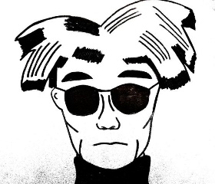
Art Department 2020 Field Trip
Where: Warhol Museum and the Mattress Factory Museum (North Side of PGH)
Where to Eat: Eat N Park Buffet (breakfast), Pizza Party at WMAHS Cafeteria(lunch)
When: Wednesday, April 15, 2020 (8:00-2:00)- students are responsible are school work missed the day of the field trip
Cost: $15 CASH ONLY (First 40 students to turn in money and permission slip will attend)
Deadline to turn money/ permission slip: Tuesday, April 7, 2020
***Turn in money and signed permission slip to Mrs. Rowe or Mr. Mann
Mrs. Rowe’s Contact Info: (412)848-4991 ext. 9208 Email: rowel@wmasd.org
The day’s itinerary:
Depart from the WMAHS campus
Eat breakfast at Eat N’ Park breakfast buffet
Depart to the Warhol Museum then tour the Warhol Museum
Depart to the Mattress Factory Museum then tour the Mattress Factory
Depart from Mattress Factory and pick up GSA from the Warhol Museum
Return to the WMAHS campus and have a pizza party lunch in the WMAHS Cafeteria
-------------------------------------------cut here------------------------------------------------
Art Department 2020 Field Trip Permission Slip
I give my child,_________________________ permission to attend the 2020 Art Department Field Trip. I understand that the trip fee is non-refundable if my child decides not to attend. He/she/they are expected to make up any class work missed the day of the field trip.
Student Name:_______________________________________ Grade Level:___________
Parent/Guardian Name:______________________________________________________
Parent Guardian Signature:_____________________________ Date:_________________
Emergency Phone Number:___________________________________________________
DEADLINE TO TURN IN PERMISSION SLIP: APRIL 7,2020-40 STUDENT LIMIT

